## horizontal line



Capstone Design Document

Robotic Air Hockey System  
2018.07.09

David Eelman - 6365316  
Stanislav Rashevskyi - 7028178  
Thomas Abdallah - 7141518

Conestoga College

Electronic Systems Engineering  
Capstone Project I - EECE74125

Semester 8, Class of 2018

horizontal line 0

Introduction 2

System Description 2

Paddle Controller 3

Master Controller 3

Puck Tracker 3

User Interface 3

Test Plans 3

Paddle Controller 3

Provides a test plan for each module more or less accurately, but some clarification required 3

Master Controller 3

Puck Tracker 3

User Interface 3

Risk Analysis 4

References 5

# Introduction

Describe document and its purpose.

The Capstone Project Proposal will make a case for the Robotic Air Hockey System and will provide a high-level description of how the project will work. The proposal document is intended for review by faculty members of the Electronic Systems Engineering (ESE) program at Conestoga College. The Robotic Air Hockey System will be capable of autonomously playing air hockey against a human player. This project will attempt to address the problem of a lack of public knowledge about the ESE program. This problem needs to be solved as there is limited marketing material available that showcases the technical knowledge and capabilities taught in the ESE program that can be understood by both technical and non-technical audiences. Our project will allow group members to develop industry relevant technologies while applying them to a fun and interactive game that will add value to the ESE program through public demonstrations.

# System Description

Describes the overall system somewhat clearly (note: the description should be such that a reader, who has technical background but no prior knowledge about the project, can easily understand. Clearly identify the newly designed and off-the-shelf sub-systems

Uses graphics (such as block/circuit/schematic/flow-chart/state-machine/3D mechanical diagrams, pictures, and tables/graph/charts of different kinds, as appropriate) in meaningful ways most of the time to describe the overall system

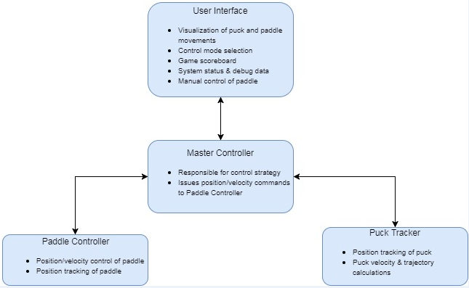

## Paddle Controller

Describes all individual modules somewhat clearly (note: the description should help a reader to understand its operation and test plans. )

## Master Controller

## Puck Tracker

## User Interface

# Test Plans

Provides a test plan for the completely integrated system more or less accurately, but some clarification required

## Paddle Controller

## Provides a test plan for each module more or less accurately, but some clarification required

## Master Controller

## Puck Tracker

## User Interface

# Risk Analysis

Addresses safety, societal and environmental issues more or less adequately

States the remaining significant risks and provides a risk management plan somewhat clearly

Based on the risks we have evaluated in the table below, we have determined that the overall risk for this project is low.

|  |  |  |  |
| --- | --- | --- | --- |
| Risk (Priority Highest to Lowest) | Category | Impact on Project Objectives | Potential Risk Reduction |
| 1. Mechanical design/integration problems | Technical | Unable to control robot motion | -Start mechanical prototyping early  -Leverage group members Mechanical Engineering experience |
| 2. Real-time object tracking problems | Technical | Unable to automate robot motion | -Start object tracking prototyping early  -Leverage proven open-source object tracking solutions |
| 3. Security of project in shared classroom | External | Lack of lab workspace availability.  Potential damage to project hardware. | -Utilize dedicated ESE lab space  -Advocate for continued support of ESE dedicated lab space |
| 4. Catastrophic loss of data | Organizational, external, technical | Schedule delays. | -Utilize source control for all project materials  -Manually back up all data once per week |
| 5. Managing scope creep | Organizational, project management | Schedule delays.  Lack of focus on core features. | -Strictly define scope of project during planning phase  -Additional features shall only be implemented after 100% completion of core project features |
| 6. System sizing incorrect | Technical, performance | Lower than desired system performance. | -Use system level performance requirements to drive component design  -Define system level performance requirements based on real-world data |
| 7. Inexperience with HMI design & implementation | Technical | Less relatable demonstration.  Worse user experience.  Difficult to debug. | -Define user interface features early (see: Managing scope creep)  -Start HMI prototyping early  -Utilize popular GUI implementation solutions |

# References

[1] "Air Hockey Robot (a 3D printer hack)", *jjrobots*, 2018. [Online]. Available: https://www.jjrobots.com/air-hockey-robot-a-3d-printer-hack/. [Accessed: 08- Feb- 2018].

[2] "AIR HOCKEY ROBOT EVO - jjrobots", *jjrobots*, 2018. [Online]. Available: https://www.jjrobots.com/the-open-source-air-hockey-robot/. [Accessed: 08- Feb- 2018].

[3] "Multiple Objects Positioning and Identification Method Based on Magnetic Localization System - IEEE Journals & Magazine", *Ieeexplore.ieee.org*, 2018. [Online]. Available: http://ieeexplore.ieee.org/document/7496898/. [Accessed: 08- Feb- 2018].

[4] H. Parekh, D. Thakore and U. Jaliya, "A Survey on Object Detection and Tracking Methods", *International Journal of Innovative Research in Computer and Communication Engineering*, vol. 2, no. 2, 2018.

[5] S. A ̊gren, *Object tracking methods and their areas of application: A meta-analysis*. 2018.

[6] "Create an Object Tracking System: Integrating Servo Control with Object Detect", *Allaboutcircuits.com*, 2018. [Online]. Available: https://www.allaboutcircuits.com/projects/create-an-object-tracking-system-integrating-servo-control-with-object-dete/. [Accessed: 08- Feb- 2018].

[7] W. Hamlet and W. Kusewich, "Using The Ultrasonic Sensor to Determine Location", *Engineering.nyu.edu*, 2018. [Online]. Available: http://engineering.nyu.edu/mechatronics/summit/SUMMIT2007/group6-Will_Bill/Summit2007Project.pdf. [Accessed: 08- Feb- 2018].

[8] "Motors and Selecting the Right One", *Learn.sparkfun.com*, 2018. [Online]. Available: https://learn.sparkfun.com/tutorials/motors-and-selecting-the-right-one. [Accessed: 08- Feb- 2018].

[9] "Linear Positioning - Motion Control Application", *Oriental Motor U.S.A. Corp.*, 2018. [Online]. Available: http://www.orientalmotor.com/applications/linear-positioning.html. [Accessed: 08- Feb- 2018].

[10] "Know Your Pneumatics: Linear Actuators", *Blog.parker.com*, 2018. [Online]. Available:   
 http://blog.parker.com/know-your-pneumatics-hints-tips-for-specifying-linear-actuators.   
 [Accessed: 08- Feb- 2018].